**User Guide for Kanban Board**

*Main page*

*Board view*

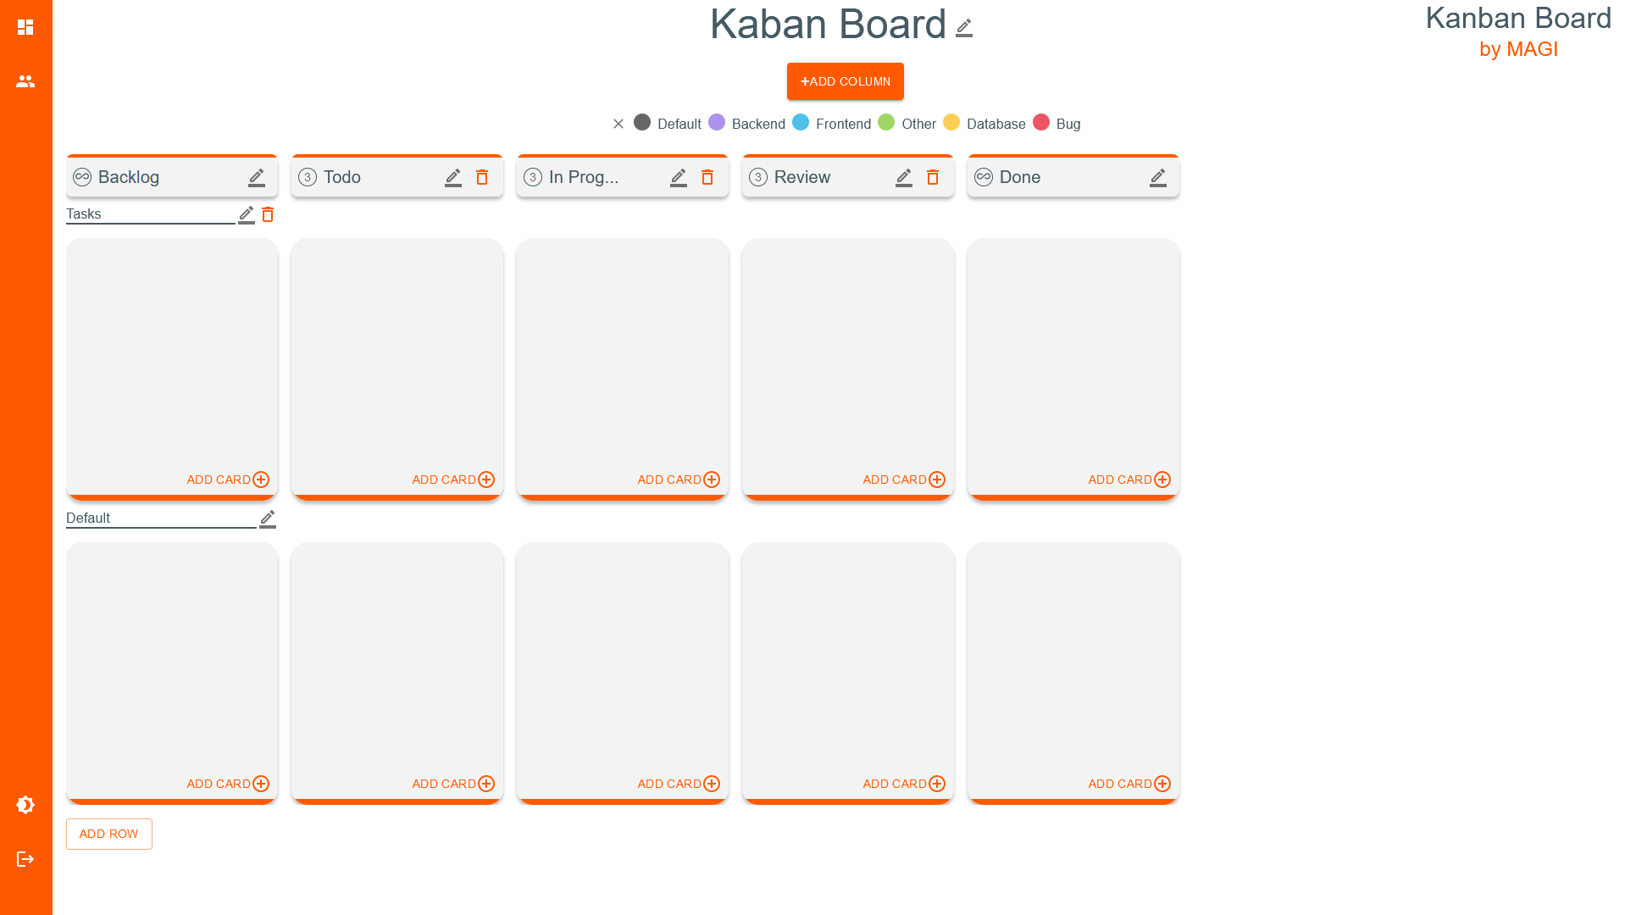

You start on the home page. You must be logged in to access the Kanban board. Only registered users can log in. Below are the functionalities that will enable you to do so.

1. Functionalities related to the entire website:

* Changing the theme to dark/light:  
   To change the theme to dark/light, click on the "Theme mode" icon.

1. Functionalities related to registration/login:

* Registration:  
  To register, press the "LOGIN" button in the upper right corner. At the bottom of the window that appeared, press the "REGISTER" button. Enter the data: name, surname, email (it is then used to log in), password (which must be confirmed by entering it a second time). Press “REGISTER”. If the entered data is correct, you will be registered, which will be confirmed by a message.
* Log in:  
  To log in, press the "LOGIN" button in the upper right corner. In the window that appears, enter the email you used to register and your password. If the provided data is correct, you will be logged in and transferred to the view with your boards.
* Logout:  
  To log out, press the logout "Logout" icon on the bottom left side panel.

All further steps assume that you are logged in.

1. Functionalities related to profile:

* Profile editing:   
  To edit user account details, in the view after logging in, select the profile icon with the caption "Edit Profile". Edit the data you want, then press "EDIT", if the entered data is correct, it will be changed.
* Adding an avatar:  
  To add an avatar, in the view after logging in, select the profile icon with the caption "Edit Profile". Press the camera icon with the caption "Upload your avatar", and then select the image from the disk that will be your avatar (the file size is maximum 128kB). After adding an avatar, refresh the page.
* Avatar change:  
  To edit an avatar, in the view after logging in, select the profile icon with the caption "Edit Profile". Press the camera icon with the caption "Upload your avatar", and then select the image from the disk that will be your new avatar (the file size is maximum 128kB). After adding an avatar, refresh the page.
* Deleting an avatar:  
  To delete an avatar, in the view after logging in, select the profile icon with the caption "Edit Profile". Tap the crossed out camera icon with the caption "Delete avatar" and then confirm the deletion.

1. Board-related functionalities:

* Board list:  
  To check the list of boards that you own or are a member of, select the board icon from the side panel with the caption "Your Boards". If you are on the home page, press the "MY PANEL" button.
* Creating a new board:  
  To create a new board, in the board list view, tap the board icon with the caption "Add Board". A window will appear in which you need to give the table a name. If the entered data is correct, a new table will be created.
* Go to a board:  
  In the board list view, tap on the name of the board you want to go to.
* Changing the board title:   
  To change the board title, click the pencil icon next to the board title. In the window that appears, enter a new title and confirm it.
* Changing the color title in the table:   
  To change the color title in the board, click the pencil icon next to the board title. In the window that appears, tap the pencil icon next to the title you want to change. Enter a new title, then confirm it.
* Checking the color legend:   
  To check the color legend, press "SHOW COLOR LEGEND".
* Adding a user to the board:  
  To add a user to the board, from the side panel, select the people icon with the caption "Users Management". In the menu that has popped up, enter the email address of the person you want to add. This person must be registered.
* Removing a user from the table:  
  To remove a user from the board, select the people icon with the caption "Users Management" from the side panel. In the menu that has popped up, select "DELETE USER FROM BOARD". From the menu that popped up on the right, select the user you want to remove from board.
* Changing the limit of user assignments to a card:   
  To change the wip limit (work in progress limit), click the pencil icon next to the board title. In the window that appeared, press the pencil icon next to "Wip limit". Enter a new limit and then confirm it by clicking the floppy disk icon.

1. Column-related functionalities:

* Adding a column:

To add a column, press the "ADD COLUMN" button and enter the column name. The standard limit of cards in a column is 3. A new column is added in the penultimate position.

* Changing the column title:   
  To change the column title, click the pencil icon next to the column title. In the window that appears, enter a new title and confirm it.
* Changing the cards limit for a column:   
  To change the cards limit for a column, click the pencil icon next to the column title. In the window that appears, enter a new card limit or select unlimited. The extreme columns have an unlimited number of cards.
* Moving a column:   
  To move a column, click and hold the column you want to move, then move it to a new position.
* Deleting a column:   
  To delete a column, click on the trashcan icon and confirm the deletion in the pop-up window. When deleting a column, all cards that are in the cells belonging to that column will be moved to the column on the left. The first and last columns cannot be deleted.

1. Row-related functionalities:

* Adding a row:

To add a row, press the "ADD ROW" button and enter the name of the row. A new row is added in the penultimate position.

* Changing the row title:   
  To change the row title, click the pencil icon next to the row title. In the window that appears, enter a new title and confirm it.
* Deleting a row:   
  To delete a row, click on the trashcan icon and confirm the deletion in the pop-up window. When deleting a row, all cards that are in the cells belonging to that row will be moved to the last row. The last row cannot be deleted.

1. Card-related functionalities:

* Adding a card:   
  To add a card, press the "ADD CARD" button in the cell to which you want to add a card and enter the name of the card, and optionally it’s description. The card will appear at the bottom of the cell.
* Changing the title of the card:   
  To change the card title, click on the 3 dots icon to the right of the card you want to edit. In the window that appears, change the title and press "EDIT".
* Changing the description of the card:   
  To change the card description, click on the 3 dots icon to the right of the card you want to edit. In the window that appears, change the description and press "EDIT".
* Card color change:  
  To change the color of the card, click on the 3 dots icon to the right of the card you want to edit. In the window that appears, press "Color" and select the color you want to assign to the card from the list.
* Moving the card:   
  To move a card, click and hold on the card you want to move, then move it to a new position in the same cell, or move it to a new position in a different cell.
* Locking a card:  
  To lock a card (prevent it from moving to another cell), click on the 3 dots icon to the right of the card you want to lock. In the window that appears, press "Lock card".
* Unlocking a card:  
  To unlock a card (allowing it to be moved to another cell), click on the 3 dots icon to the right of the card you want to unlock. In the window that appears, press "Unlock card".
* Adding a subtask to a card (list of subtasks):   
  To add a subtask to card, click on the 3 dots icon to the right of the card to which you want to add a subtask. In the window that appears, press the plus icon next to "Add new subtask". Enter a subtask title, then confirm with the plus icon.
* Editing a subtask (list of subtasks):   
  To edit a subtask, click on the 3 dots icon to the right of the card where you want to edit the subtask. In the window that appears, tap the pencil icon next to the subtask you want to edit. Enter a new subtask title, then confirm your changes with the floppy disk icon.
* Task completion approval (list of subtasks):   
  To confirm the completion of a subtask, click on the 3 dots icon located to the right of the card in which you want to confirm the completion of the subtask. In the window that appears, press the checkbox next to the subtask you want to confirm.
* Canceling subtask completion (list of subtasks):  
  To cancel a subtask completion, click on the 3 dots icon to the right of the card where you want to cancel the subtask completion. In the window that appears, press the checkbox next to the task you want to cancel completion.
* Deleting a subtask (list of subtasks):   
  To delete a subtask, click on the 3 dots icon to the right of the card where you want to delete the subtask. In the window that appears, press the trash can icon next to the subtask you want to delete. Confirm subtask deletion.
* Deleting a card:   
  To delete a card, click on the 3 dots icon to the right of the card you want to delete. In the window that appears, press "DELETE" and then confirm the deletion.
* Assigning a user to a card:  
  To assign a user to a card, from the side panel, select the people icon with the caption "Users Management". In the menu that has popped up, there is a "Drag member to card" section. Press the avatar of the user you want to assign to the card (when hovering over the avatar, the full user name is displayed), hold and then drag and drop the avatar on the card to which you wanted to assign it. The remaining possible number of user assignments to cards is displayed in a circle next to the avatar. If it drops to zero, the user cannot be assigned to the next card.
* Removing a user from the card:  
  To remove a user from a card, click on the 3 dots icon to the right of the card from which you want to remove them. In the window that appears, press "Users" and select the user you want to remove from the list from the card, and then confirm your choice.
* Adding a child's card:  
  To add a card child, click on the 3 dots icon to the right of the card to which you want to add a child. In the window that appears, press "Add child" and select the child you want to add to this card from the list, and then confirm your choice.
* Removing of a child's card:  
  To remove a child from a card, click on the 3 dots icon to the right of the card from which you want to remove a child. In the window that appears, press "Children" and select the child you want to remove from this card from the list, and then confirm your choice.